ANDREW INGALLS

CPSC 230 – Computer Science I

Spring 2022

Examination I

This examination is open book and notes. There are 6 questions and 50 points. You have 50 minutes to earn as many points as you can. Good luck!

.

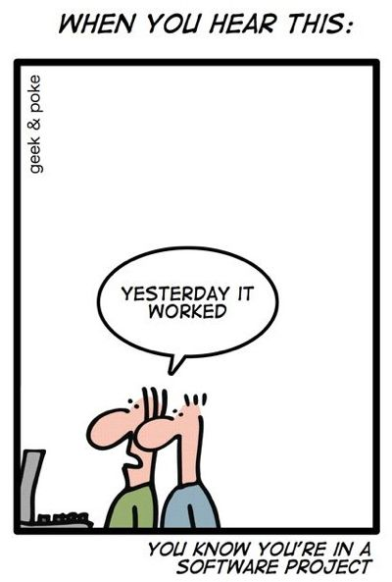

1. **(5 Points)** Answer the following:

What is the difference between editor and IDE?

* Editor can be used to type or edit text in general or use for typing for a programming language whereas an IDE is usually integrated with a certain programming language so it can function and contains a text editor within itself.

When using the input function, by default, what is the type of the object created?

* A **string** is the default type of object created with input function

1. **(10 Points)** Convert the following to binary/decimal as specified. Show your work.
2. 82 to binary

**1010010**

64+0+16+0+0+2+0

1. 110111 to decimal

32+16+0+4+2+1

**55**

1. **(10 points)** Write a Python module that prompts the user for a number and displays the square root of that number.

1. **(10 points)** Ask the user to enter a number between 10 and 20 (inclusive). If they enter a number within this range, display the message “Thank you”, otherwise display the message “Incorrect answer”. Keep asking until **Exit** is typed by the user.

1. **(10 points)** Ask the user how many times they want to see **It is OK!** gets printed. Using **for loop** print It is OK! that many times.

1. **(5 points)** (NO PENALTY FOR CONSTRUCTIVE CRITICISM.)

What is your impression of the course so far?

I have really been enjoying it so far. I think the in-class assignments and activities are really informative and fun to make. Zybooks is a little tough sometimes because a lot of the time we haven’t covered the concepts yet when I try to complete the module before Friday, but I still end up figuring most of it out by the end of the week. It’s a fun course and I’m eager to learn more.

What have you enjoyed most about this course so far?

I think I’ve enjoyed just learning about python because I’ve always been interested in computer science. The best part by far is when you create something all by yourself and it actually works. Such a great feeling.

Is there anything you would like to see changed in the course content or the instructor teaching style?

* I think so far the course is going pretty well. I really like how we use some time in class to go over the Zybooks questions because some of them can be tough. I think right now the course is challenging, but just enough where its attainable to do well.